**Beyond QWERTY Form Filling Project: A Visual Implementation roadmap steps**

**1. User Interface (UI) Design**

**Voice Command Interface:**



1. Once the user speaks their name, the text box updates to display the recognized text, and the progress bar stops.

**Handwriting Recognition Interface:**

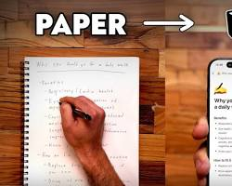

1. A handwriting recognition interface is a digital tool that allows users to input text by handwriting on a screen. It uses advanced algorithms to recognize the handwritten characters and convert them into digital text.

**2. Backend Architecture**

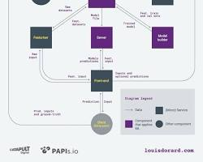

backend architecture diagram showing components like API server, database, speechtotext service, handwriting recognition service, and machine learning model

**3. Machine Learning Model**

machine learning model architecture, e.g., a neural network for form field extraction

**4. Integration with Healthcare Systems**

diagram showing the integration of the Beyond QWERTY system with EHRs, insurance systems, and other healthcare systems

**Implementation Steps:**

**1 Data Collection and Preparation:**

* Gather a diverse dataset of forms and user input.
* Clean and preprocess the data to remove noise and inconsistencies.
* Annotate the data to identify form fields and their corresponding data types.

**2 Model Training:**

* Train a machine learning model on the annotated dataset to recognize form fields and extract relevant information.
* Experiment with different model architectures and hyperparameters to achieve optimal performance.
* Continuously retrain the model with new data to improve accuracy and adaptability.

**3 API Development:**

* Create RESTful APIs to handle user input, process data, and interact with external systems.
* Implement robust error handling and security measures to protect sensitive data.
* Optimize API performance for efficient processing of user requests.

**4 Frontend Development:**

* Design an intuitive and user-friendly interface that seamlessly integrates voice and handwriting input.
* Implement real-time feedback mechanisms to keep users informed about the system's understanding.
* Provide clear instructions and error messages to guide users through the form filling process.

**5 Deployment and Testing:**

* Deploy the application to production servers, ensuring scalability and reliability.
* Conduct rigorous testing to identify and fix bugs and performance issues.
* Monitor the system's performance and gather user feedback to make continuous improvements.